BIOL 430
Institutional Affiliation
Professor’s Name
Student’s Name
Date

1.If you are lifting a 10lb weight, provide a physiological explanation as to why you can continue to hold the weight for a long period without experiencing fatigue.
Weight lifting is categorized as anaerobic exercise. It is also known as strength training. The peak contraction attained by muscles depicts muscular strength. The capability of the muscles to contract contrary to resistance is termed muscular endurance. Endurance training doesn’t amplify the length of fibers. Instead, it raises the number of myoglobin in the muscle fiber as well as improving the ability to obtain Adenosine trisphosphate from oxidative phosphorylation.
Endurance training, therefore, reduces the quantity of fast glycolytic muscle fibers and raises the amount of fast oxidative fibers. It declines the body fats and intensifies cardiac efficiency as well as O₂ (oxygen) uptake. Therefore, the physiological alterations that take place all through strength training explain why one can continue holding weights for a long time without experiencing muscle fatigue. The mechanisms are; growth in the sum of myofibrils as a result of their multiplication enlarged size as well as thickness of the connective tissue of the muscles and lastly, improved glycogen reserves which offer energy for the process of contraction.
2. Draw and label the three phases of a muscle twitch on a myogram.
The three phases involved in a muscle twitch on a myogram include; latent period or lag phase, the contraction phase, and the relaxation phase. The lag phase is usually the duration the occurs between stimulus application and instigation of contraction. This phase normally takes approximately fifteen to twenty milliseconds. The latent phase is usually progressed by the contraction period which is a phase where the tension in the muscle fibers is usually at its topmost. This phase lasts for approximately fifteen to twenty milliseconds. Lastly, in the relaxation phase, during this period the tension declines followed by diminishing of the electric potential. This, in turn, brings about tension in the motor till it's back to the rest state which normally takes about fifty to sixty milliseconds. Although time varies from one muscle to another.
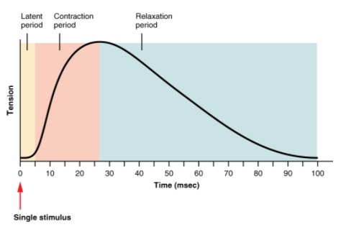

3. Explain the steps that initiate a muscle contraction beginning with an action potential arriving at the neuromuscular junction until the muscle fiber shortens. Include all details and mechanisms covered in class.
Skeletal muscles aid in moving the body mechanically, through their contraction and relaxation. The nervous system sends messages that cause the contraction of muscles. The entire process of muscle contraction is known as the mechanism of muscle contraction. The process involves various steps which include the following. The first step involves the triggering of chemical reactions which is brought about by a message that travels to the muscular system from the nervous system. Muscle contraction starts when the nervous system produces a signal. The signal is usually known as an action potential and it is an impulse that travels through a nerve known as a motor neuron. The motor neuron reaches a muscle cell at the neuromuscular junction. The skeletal muscle tissue is made up of cells known as muscle fibers. However, when the signal arrives at the neuromuscular junction, the motor neuron causes the release of acetylcholine (neurotransmitter). The acetylcholine binds to the receptors of muscle fibers, on the outer side, which in turn initiates a chemical reaction in the muscle.
Diagram showing the first step.
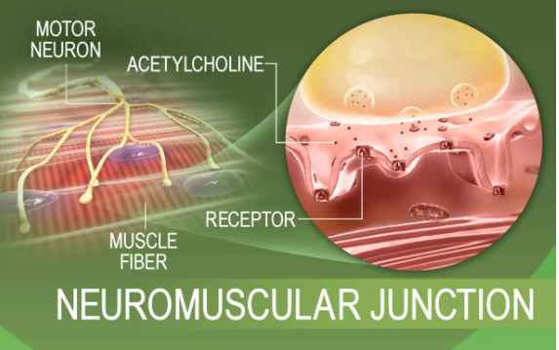

The second step is muscle contraction A multistep molecular process inside the fibers starts when acetylcholine attaches to receptors on the membrane of the muscle fiber. The proteins found in the muscle fibers are arranged into elongated chains. These chains are capable of interacting with each other hence restructuring to condense and relax. When acetylcholine arrives at the receptors of muscle fiber membranes, the channels of the membranes open and the progression that causes contraction of the relaxed muscle fibers to commence; open channels permit an entry of sodium ions into the muscle fiber cytoplasm. Also, the influx of sodium sends a message in the muscle fibers to generate the production of stored Ca²⁺ ions (calcium ions). The Ca²⁺ ions diffuse to enter the muscle fiber. This in turn results in to change in the relationship amid the protein chains in the muscle cells hence causing contraction.
Diagram showing the second step.
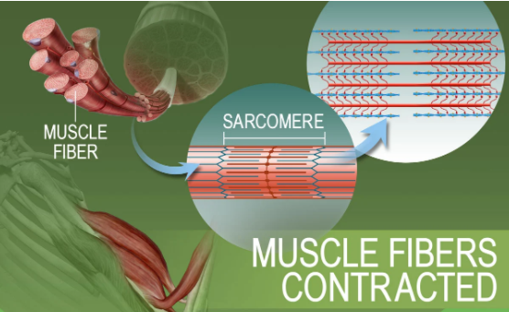
The last step is muscle fiber relaxation. This happens when motor neuron stimulation stops providing impulses to the muscle fibers. Also, the chemical reaction that leads to the reorganization of proteins of muscle fibers stops. All this process, in turn, reverses all the chemical progression in the muscle fiber hence leading to muscle relaxation.
Diagram showing the last step.
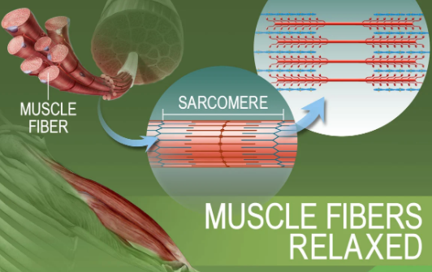

4. Which type of skeletal muscle fibers would you expect a sprinter to have? A marathoner? Why?
Sprinters usually have two types of skeletal muscle fibers which include type I or slow-twitch and type II also known as fast-twitch. The slow-twitch muscle fibers are useful in supporting long-distance stamina activities such as marathon running. On the other hand, fast-twitch muscle fibers are used in supporting quick and powerful moments like weightlifting.
5. The reactions showing creatine kinase catalyzing the creatine/creatine-phosphate reaction proceed in both directions. What then determines the direction that the reaction goes at any given moment? (Hint: think about what we discussed in the first unit on reversible reactions.
Creatine kinase plays a vital role in catalyzing the synthesizing of phosphocreatine as well as ATP in a reversible Lohmann reaction. However, the relative concentrations of both the products and reactants determine the route that the reaction goes at any given instant since creatine kinase catalyzes the reaction in both directions.
6. When curare, a South American arrow poison, is placed on a nerve-muscle preparation, the muscle does not contract when the nerve is stimulated, even though a neurotransmitter is still being released from the nerve. Give a possible explanation for the action of curare (be sure to include specific details explaining how and why).
Curare is obtained from a plant known as Strychnos and it is obtained from either stem or root. This plant is mostly found in South American. In the olden days, Curare was used for anesthesia since it was a primary paralytic agent. It however induces muscle relaxation.
Action mechanism of Curare.
Curare is a non-depolarizing neuromuscular blocker and also it is an opponent of nicotinic acetylcholine receptors, thus it competes with acetylcholine for attachment sites. Normally, postsynaptic nicotinic receptors are accountable for the production of the action potential which leads to contraction. However, when the binding of Curare stops action potential from taking place at the membrane of postsynaptic, this results in relaxation of voluntary muscles even in the presence of acetylcholine.
7. What is the response of a muscle fiber to an increase in the firing rate of a neuron at the neuromuscular junction?
The muscle fibers contract at once when the motor neuron fires. The summation of successive contraction of muscles increases with an upsurge in the firing rate of the neuron till it reaches limits. However, when the successive action potentials don’t produce muscle contraction summation, since the muscle has reached the peak state of contraction, the muscle is said to be in a state known as tetanus.
How does the nervous system increase the force of contraction in a muscle composed of many motor units?
Motor neurons use a rate code to indicate the quantity of force that is extended by a muscle. A rise in the action potentials rate which is fired by the motor neuron leads to intensification in the quantity of force generated by the motor unit.
8. Without ATP, a relaxed muscle cannot contract and a contracted muscle cannot relax. Explain why.
Adenosine trisphosphate abbreviated as ATP is a molecule that carries energy and is found in cells of living things. The main function of this molecule is to provide oxygen for usage and storage in the cells. However, without ATP, a relaxed muscle can’t contract and a contracted muscle can’t relax. This is because ATP is compulsory for muscle contraction and relaxation. In relaxation, ATP is needed for the active transportation pumps that play the role of removing calcium ions from the cytosol and return the same ions to the sarcoplasmic reticulum, myosin detachment from actin. In contraction, ATP is necessary for activating myosin before binding to the active sites of actin.
9. Botulism occurs when a bacterium, Clostridium botulinum, releases a neurotoxin that prevents motor neurons (at neuromuscular junctions) from releasing ACh. In view of this, what early signs of botulism would you predict to observe?

Botulism is a lethal disease, though it is rare, triggered by toxins that are produced by bacteria known as Clostridium botulinum. Some of the early signs of botulism are; difficulty in speaking and swallowing, nausea and vomiting, paralysis, trouble breathing, and blurred vision.
Explain why a person could die of suffocation.
when an individual inhales carbon monoxide (CO), it combines with the RBC (red blood cells) that carries blood to the body. Excess inhalation of CO makes blood unable to carry the oxygen hence leading to suffocation and death. So, lack of oxygen supply to the body’s vital organs causes suffocation which could lead to death.

